SWT 22022 – Practical for Internet Application Development
Department of Information and Communication Technology
Faculty of Technology
Lab sheet :15
Reg. Number: SEU/IS/20/ICT/084
Academic Year :2020/2021
Date: 2024.10.24
Practical No :16

Title:
- HR Management System - II
Aims:
• Implement routes for views
• Implement views
Tasks:
• Update the APIs
• Update controller
• Create blade files

Activities :

1. Update the APIs

// For views
Route::get('employee', [EmployeeController::class, 'index']);
Route::get('employee/create', [EmployeeController::class, 'create']);
Route::get('employee/{id}/edit', [EmployeeController::class, 'edit']);
// For CRUD Operation
// Create
Route::post('employee/store', [EmployeeController::class, 'store']);
// Read
Route::get('employee/all', [EmployeeController::class, 'all']);
// Update
Route::post('employee/{id}', [EmployeeController::class, 'update']);
// Delete
Route::delete('employee/{id}', [EmployeeController::class, 'delete']);

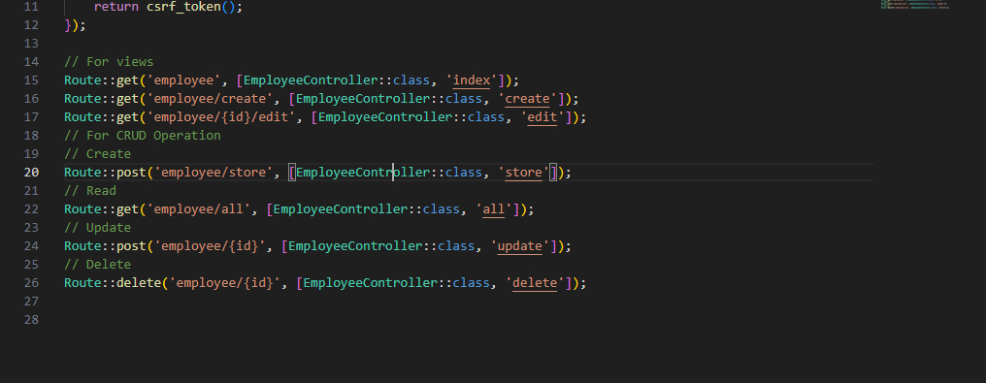

- Update controller

<?php
namespace App\Http\Controllers;
use App\Http\Requests\StoreEmployeeRequest;
use App\Models\Employee;
use Illuminate\Http\Request;

class EmployeeController extends Controller
{
public function index(){
$employees = Employee::all();
return view('employee.index', compact('employees'));
}
public function create(){
return view('employee.create');
}

public function store(StoreEmployeeRequest $request)
{

Employee::create($request->validated());
return redirect('employee')->with('success', 'Employee created successfully.');
}
public function edit($id)
{
$employee = Employee::findOrFail($id);
return view('employee.edit', compact('employee'));
}
public function update(Request $request, $id){
$employee = Employee::findOrFail($id);
$employee->update($request->all());
return redirect('employee')->with('success', 'Employee updated successfully.');
}
public function delete($id){
$employee = Employee::findOrFail($id);
$employee->delete();
return redirect('employee')->with('success', 'Employee deleted successfully.');
}

}

  - Create blade files
I. layout.blade.php
II. index.blade.php
III. create.blade.php
IV. edit.blade.php

layout.blade.php

<!DOCTYPE html>
<html lang="en">
<head>
<meta charset="UTF-8">
<meta name="viewport" content="width=device-width, initial-scale=1.0">
<meta http-equiv="X-UA-Compatible" content="ie=edge">
<link href="https://cdn.jsdelivr.net/npm/bootstrap@5.3.3/dist/css/bootstrap.min.css" rel="stylesheet">
<script src="https://cdn.jsdelivr.net/npm/bootstrap@5.3.3/dist/js/bootstrap.bundle.min.js"></script>
<title>HR Management System</title>
</head>
<body>
<div class="container">
@yield('content')
</div>
</body>
</html>

index.blade.php

@extends('employee.layout')

@section('content')
<div class="mt-5 card">
<h2 class="card-header">Employee Details</h2>
<div class="card-body">
<table class="table table-bordered">
<thead>
<tr>
<th>Name</th>
<th>Role</th>
<th>Salary</th>
<th>Age</th>
<th>Actions</th>
</tr>
</thead>
<tbody>
@forelse ($employees as $employee)
<tr>
<td>{{ $employee->name }}</td>
<td>{{ $employee->role }}</td>
<td>{{ $employee->salary }}</td>
<td>{{ $employee->age }}</td>
<td>
<a href="{{ url('employee/edit/' . $employee->id) }}" class="btn btn-warning btn-sm">Edit</a>
</td>
</tr>
@empty
<tr>
<td colspan="5">There are no employees.</td>
</tr>
@endforelse
</tbody>
</table>
</div>
</div>
@endsection

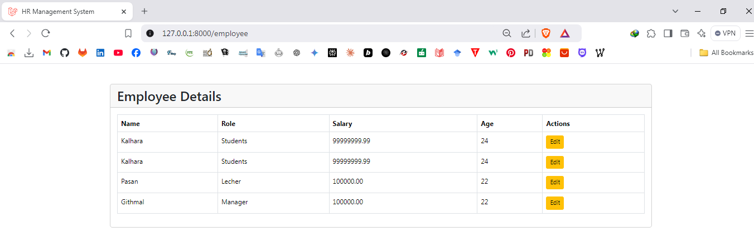

edit.blade.php

@extends('employee.layout')

@section('content')
<div class="mt-5 card">
<h1 class="card-header">Edit Employee</h1>
<div class="card-body">
<form action="{{ url('employee/update/' . $employee->id) }}" method="post">
@csrf
<div>
<label for="name" class="form-label">Name</label>
<input type="text" name="name" class="form-control" id="name" value="{{ $employee->name }}" placeholder="Enter your name">
</div>
<div>
<label for="role" class="form-label">Role</label>
<input type="text" name="role" class="form-control" id="role" value="{{ $employee->role }}" placeholder="Enter your role">
</div>
<div>
<label for="salary" class="form-label">Salary</label>
<input type="number" name="salary" class="form-control" id="salary" value="{{ $employee->salary }}" placeholder="Enter your salary">
</div>
<div>
<label for="age" class="form-label">Age</label>
<input type="number" name="age" class="form-control" id="age" value="{{ $employee->age }}" placeholder="Enter your age">
</div>
<button type="submit" class="mt-2 btn btn-primary">Update</button>
</form>
</div>
</div>
@endsection
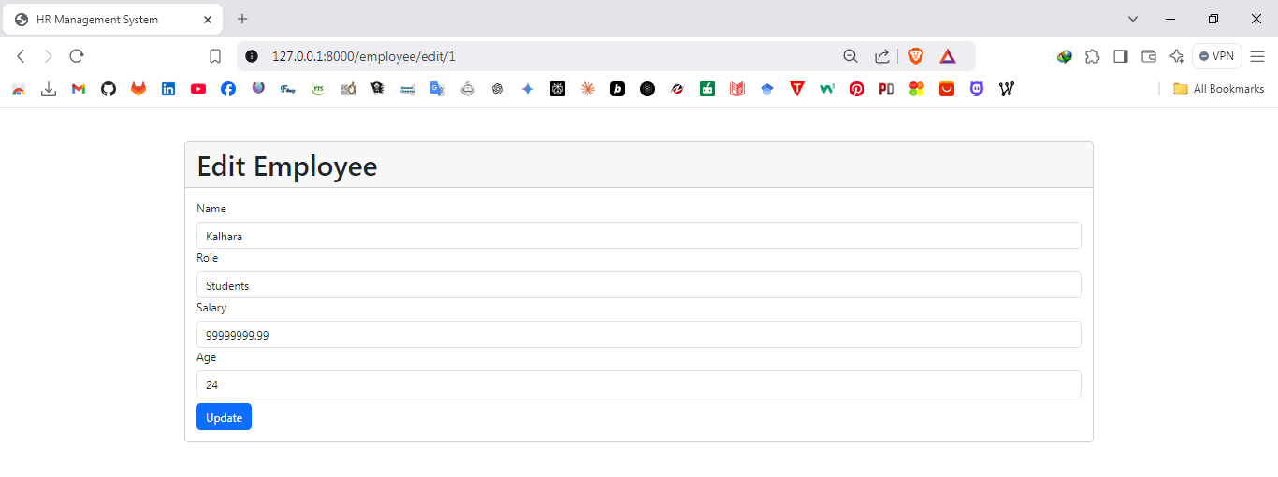

create.blade.php

@extends('employee.layout')

@section('content')
<div class="mt-5 card">
<h1 class="card-header">Add New Employee</h1>
<div class="card-body">
<form action="{{ url('employee/store') }}" method="post">
@csrf
<div>
<label for="name" class="form-label">Name</label>
<input type="text" name="name" class="form-control" id="name" placeholder="Enter your name">
</div>
<div>
<label for="role" class="form-label">Role</label>
<input type="text" name="role" class="form-control" id="role" placeholder="Enter your role">
</div>
<div>
<label for="salary" class="form-label">Salary</label>
<input type="number" name="salary" class="form-control" id="salary" placeholder="Enter your salary">
</div>
<div>
<label for="age" class="form-label">Age</label>
<input type="number" name="age" class="form-control" id="age" placeholder="Enter your age">
</div>
<button type="submit" class="mt-2 btn btn-success">Add</button>
</form>
</div>
</div>
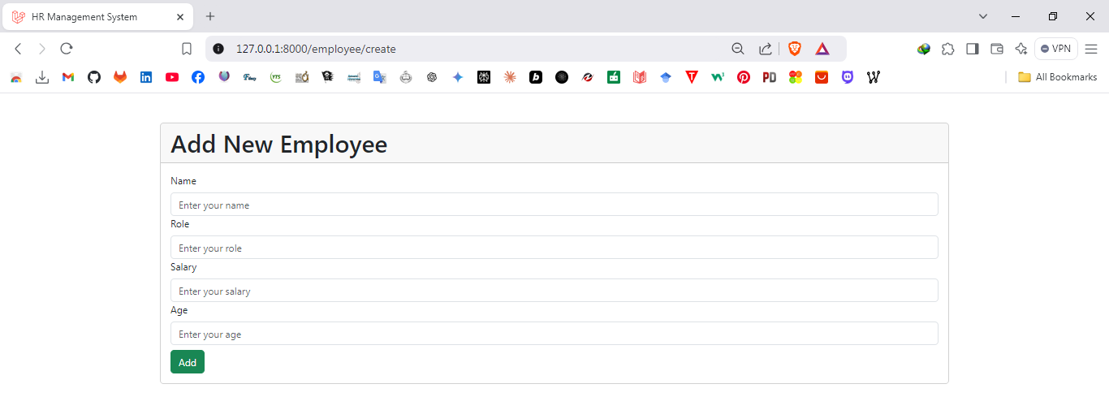
@endsection

web.php

<?php

use Illuminate\Support\Facades\Route;
use App\Http\Controllers\EmployeeController;
Route::get('/', function () {
return view('welcome');
});

Route::get('/token', function () {
return csrf_token();
});

Route::get('employee', [EmployeeController::class, 'index']);
Route::get('employee/create', [EmployeeController::class, 'create']);
Route::post('employee/store', [EmployeeController::class, 'store']);
Route::get('employee/edit/{id}', [EmployeeController::class, 'edit']);
Route::post('employee/update/{id}', [EmployeeController::class, 'update']);
Route::delete('employee/delete/{id}', [EmployeeController::class, 'delete']);

EmployeeController.php

<?php

namespace App\Http\Controllers;

use App\Models\Employee;
use App\Http\Requests\StoreEmployeeRequest;
use Illuminate\Http\Request;

class EmployeeController extends Controller
{
public function index()
{
$employees = Employee::all();
return view('employee.index', compact('employees'));
}

public function create()
{
return view('employee.create');
}

public function store(StoreEmployeeRequest $request)
{
Employee::create($request->validated());
return redirect('employee')->with('success', 'Employee created successfully.');
}

public function edit($id)
{
$employee = Employee::findOrFail($id);
return view('employee.edit', compact('employee'));
}

public function update(Request $request, $id)
{
$employee = Employee::findOrFail($id);
$request->validate([
'name' => 'required|string|max:255',
'role' => 'required|string|max:255',
'salary' => 'required|numeric|min:0',
'age' => 'required|integer|min:18|max:65',
]);

$employee->update($request->all());
return redirect('employee')->with('success', 'Employee updated successfully.');
}

public function delete($id)
{
$employee = Employee::findOrFail($id);
$employee->delete();
return redirect('employee')->with('success', 'Employee deleted successfully.');
}
}

StoreEmployeeRequest.php

<?php

namespace App\Http\Requests;

use Illuminate\Foundation\Http\FormRequest;

class StoreEmployeeRequest extends FormRequest
{
public function rules()
{
return [
'name' => 'required|string|max:255',
'role' => 'required|string|max:255',
'salary' => 'required|numeric|min:0',
'age' => 'required|integer|min:18|max:65',
];
}
}

Discussion:
- In this lab session titled "HR Management System - II", we focused on enhancing our Laravel project by implementing new features and refining the existing structure. The primary goal was to establish seamless navigation through proper route definitions for various views, such as creating, listing, and editing employees. We concentrated on updating APIs to ensure they aligned with the application’s requirements, which included revisiting controller logic for better CRUD operations. Additionally, we worked on creating and improving Blade files to provide an intuitive and functional user interface for tasks like adding, editing, and managing employees. This practical session emphasized integrating back-end and front-end functionality, which deepened my understanding of Laravel’s routing, controller logic, and Blade templating, ultimately leading to a more robust and dynamic HR Management System.

